Creating instance on Amazon EC2

Click on all services and then select EC2

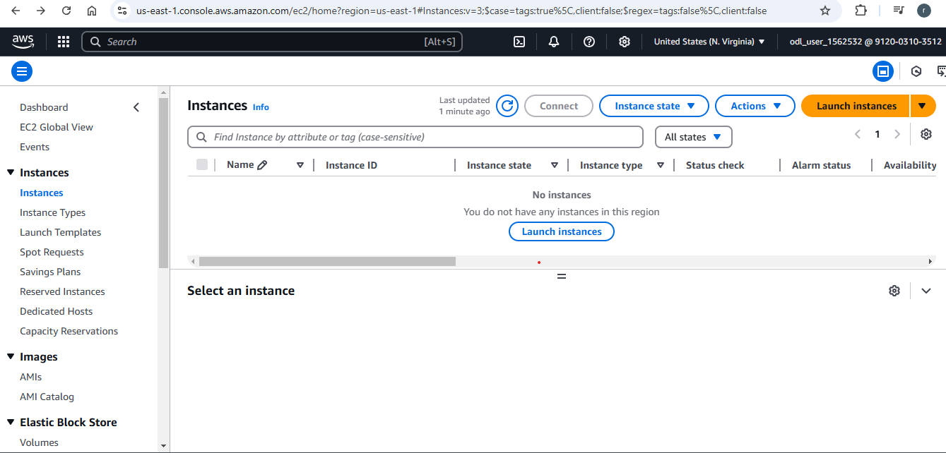

Then click on launch instance

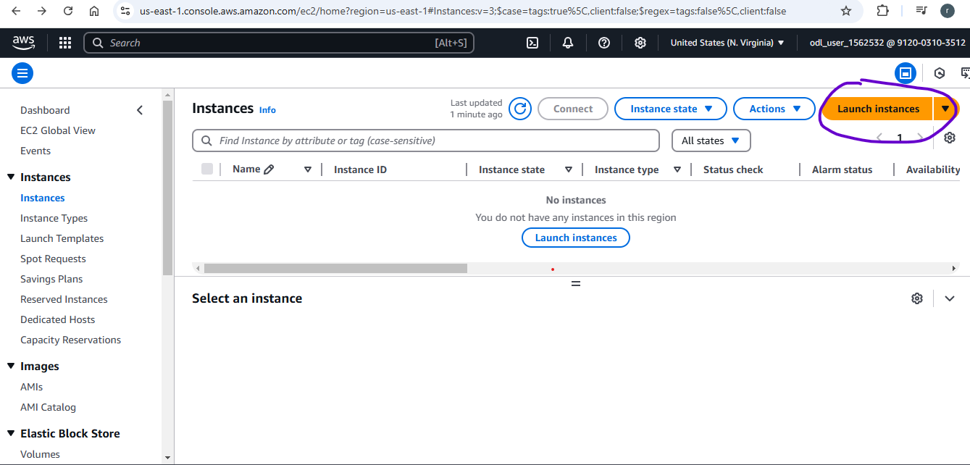

You will see the next screen

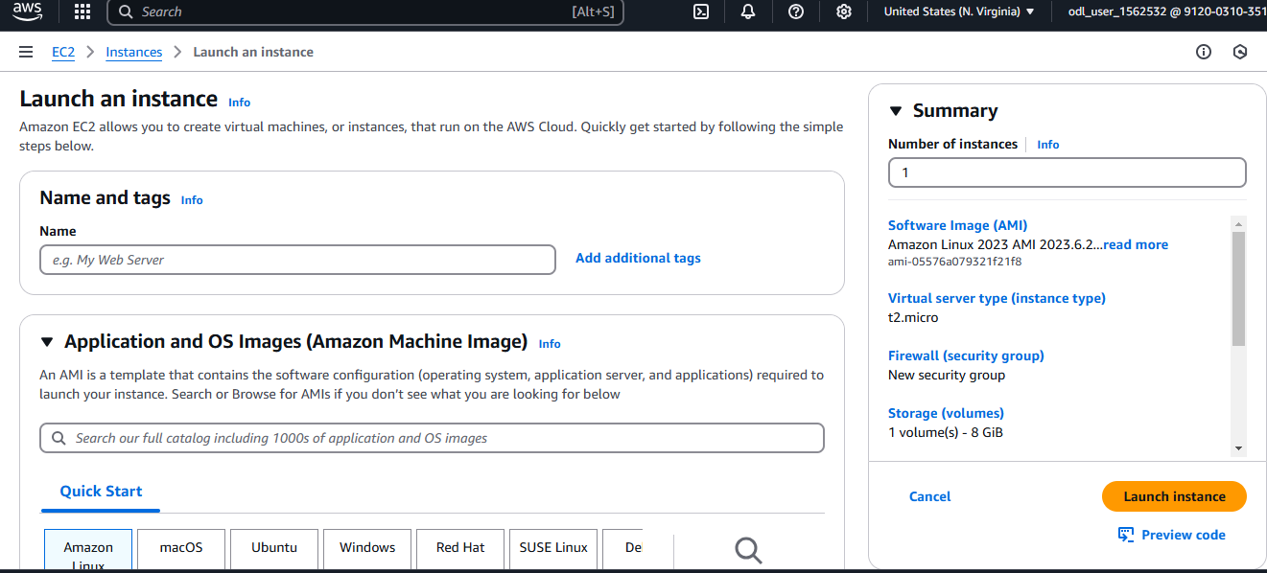

Give it a name as instance 1

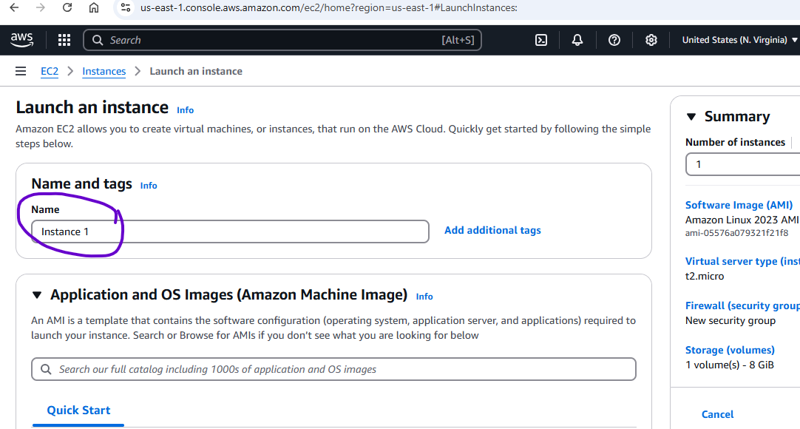

Then in summary how many servers you want to create , I would 1 for now

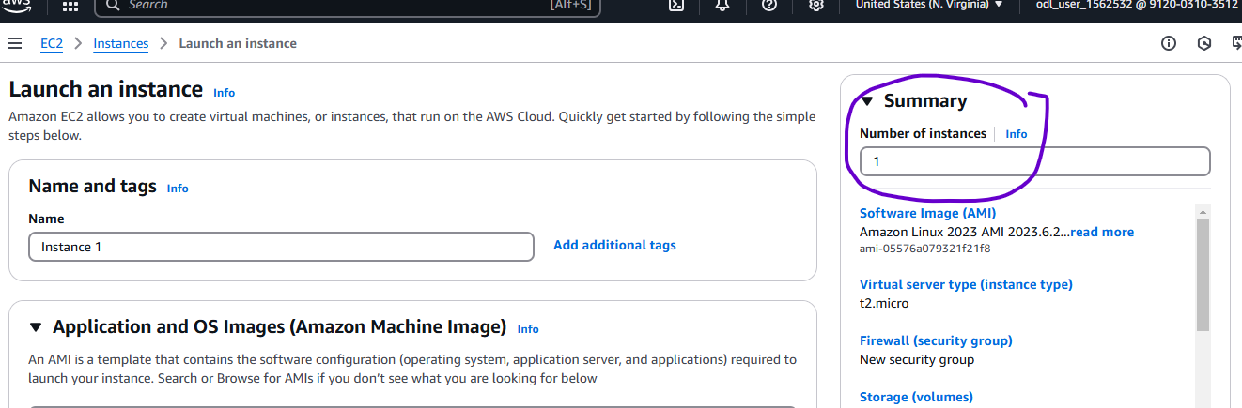

Scroll down and you will see window servers , if you choose windows

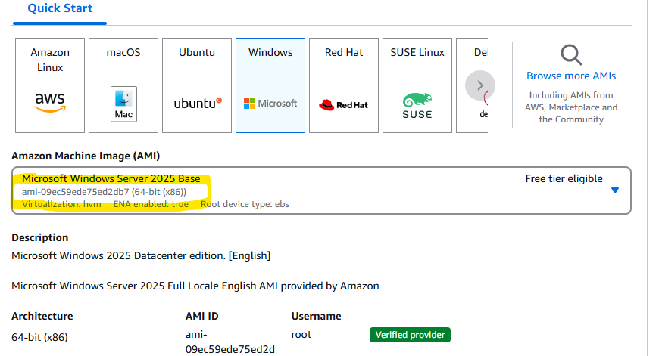

Instance type, how much configuration you are looking for 4 gb RAM ..

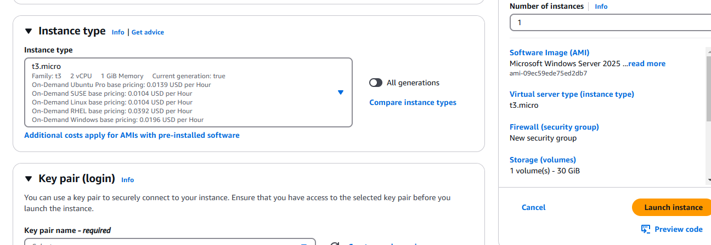

This is the key pair click on create key pair

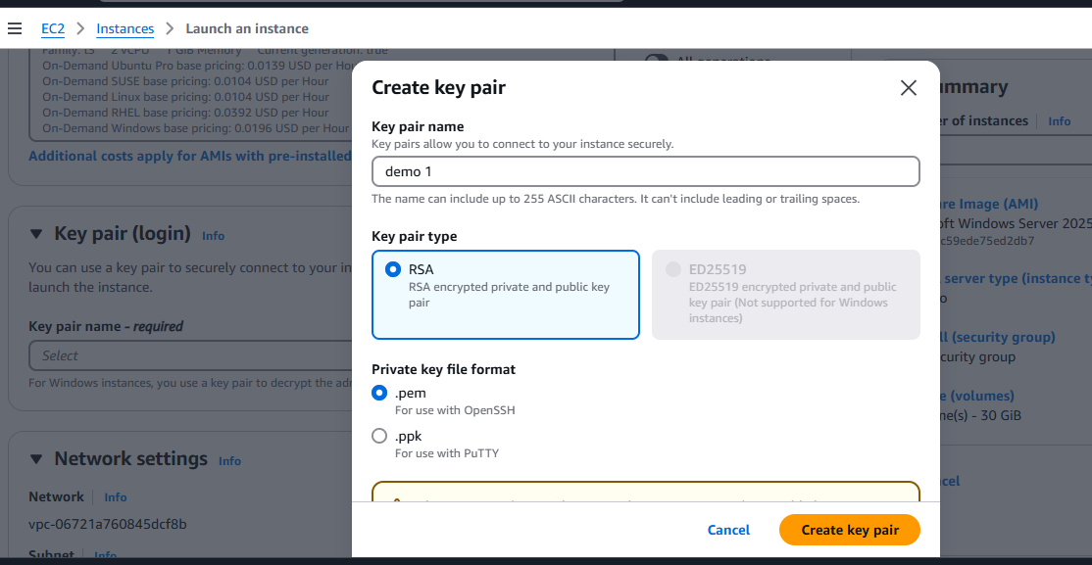

Once you will click on create key pair it will create a private key and you can’t share anyone

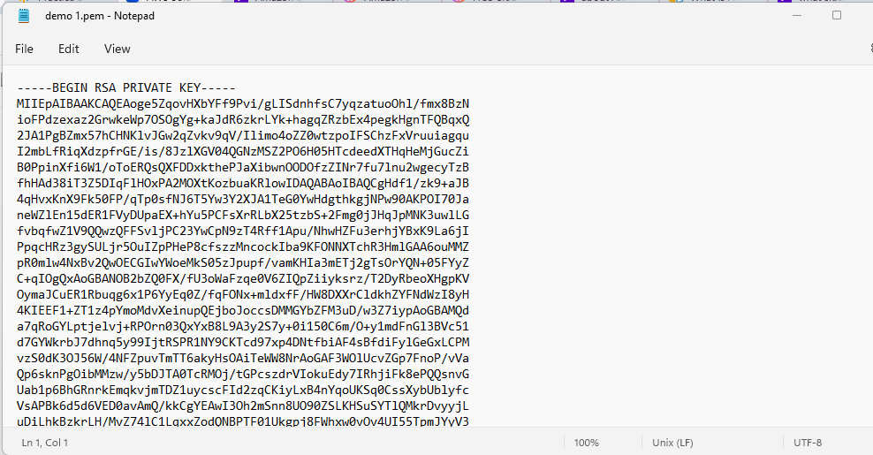

Then do the network settings:

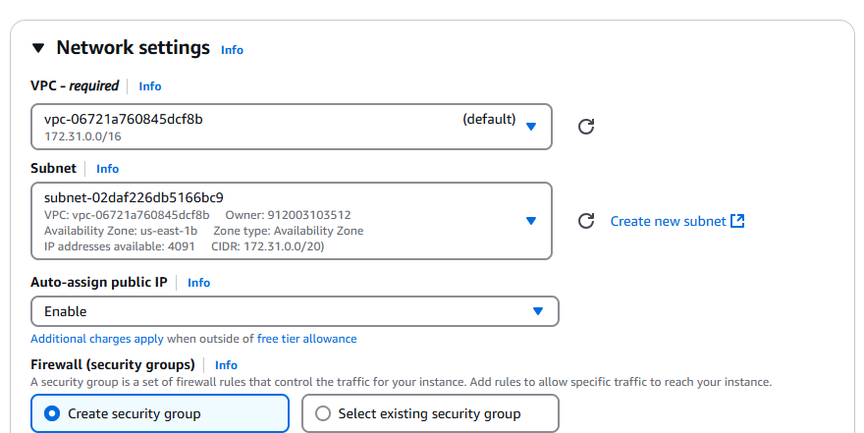

In security group rdp which is remote desktop protocol

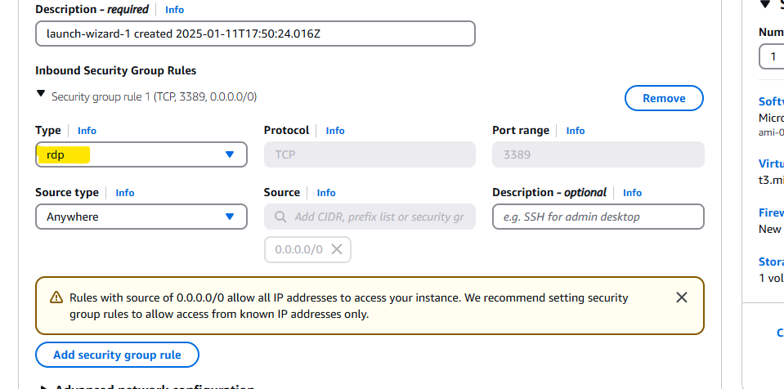

Getting error

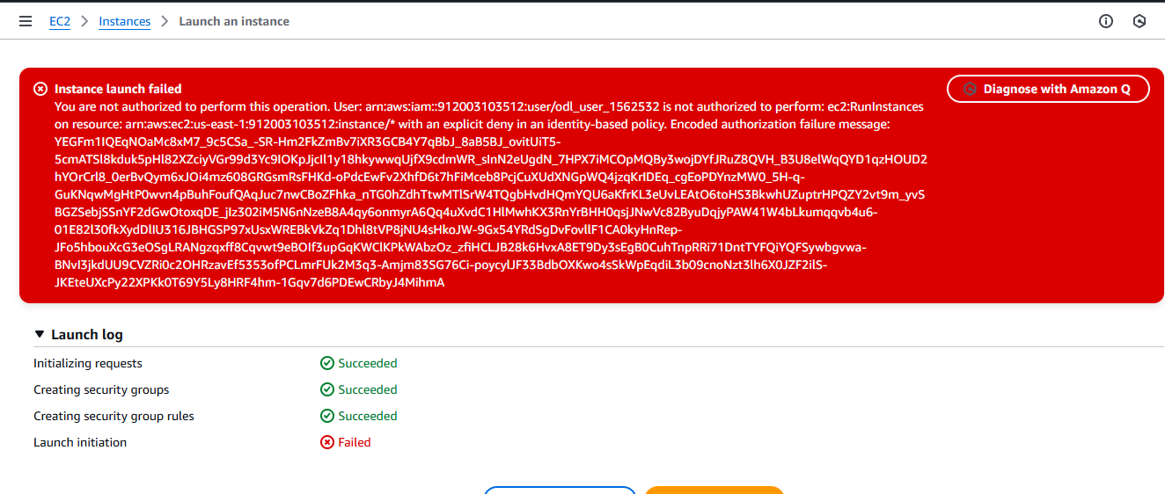

The instance created and it is succuessful :

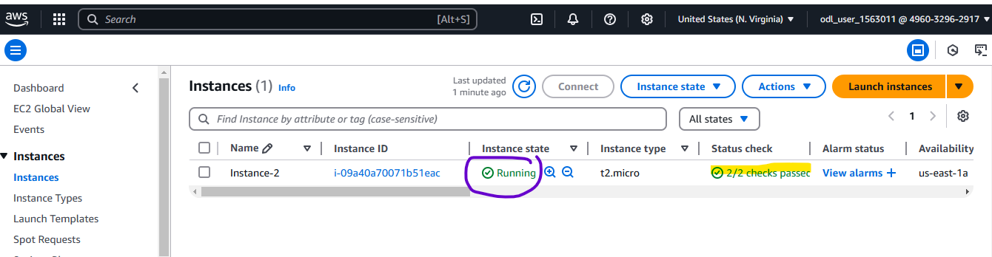

Then click on RDP client (tab) then click on download

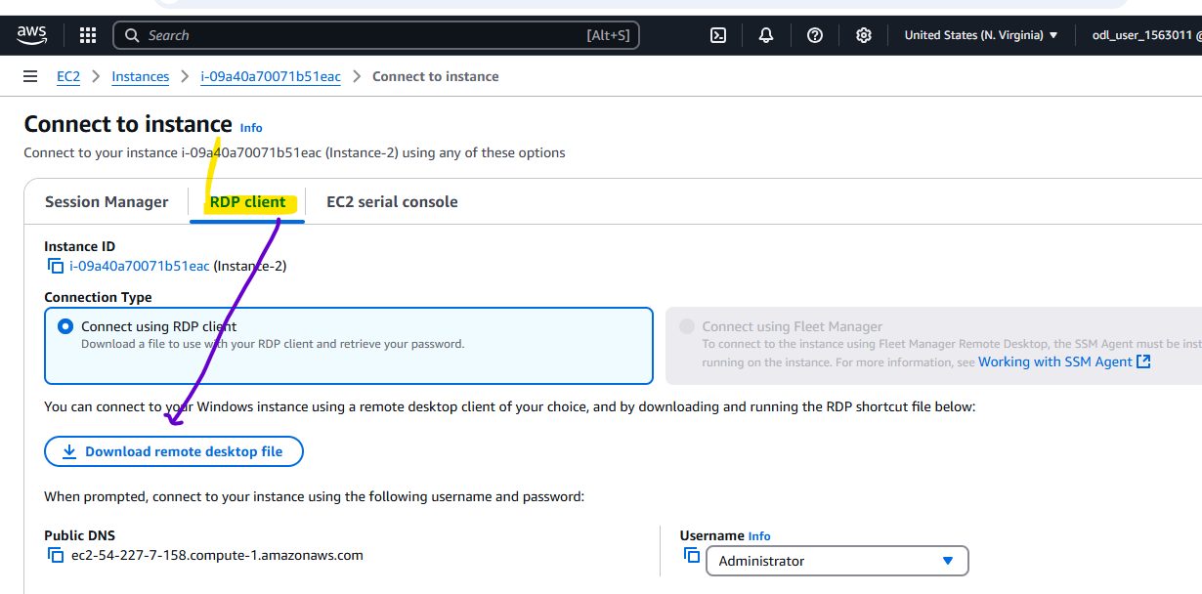

After connecting and download of virtual machine it will ask for password then

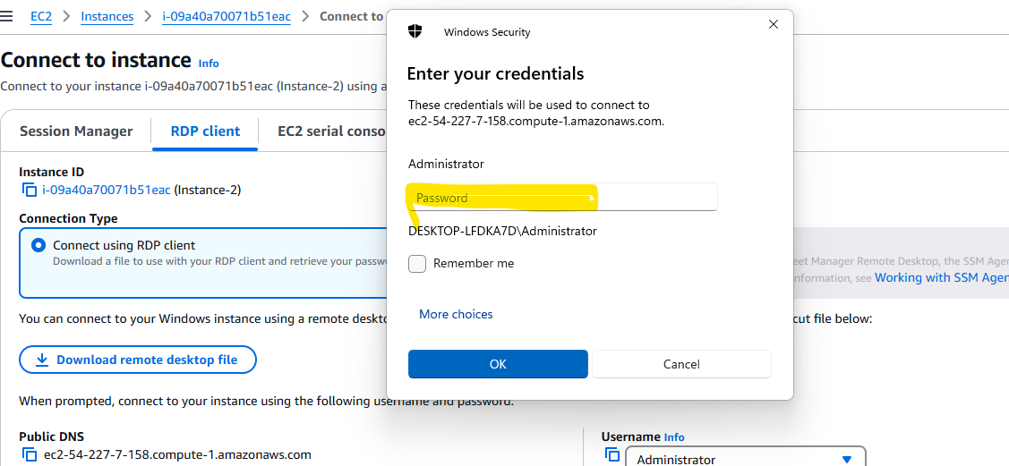

Then go back to instance then action -> dropdown 🡪 Security 🡪Get window password

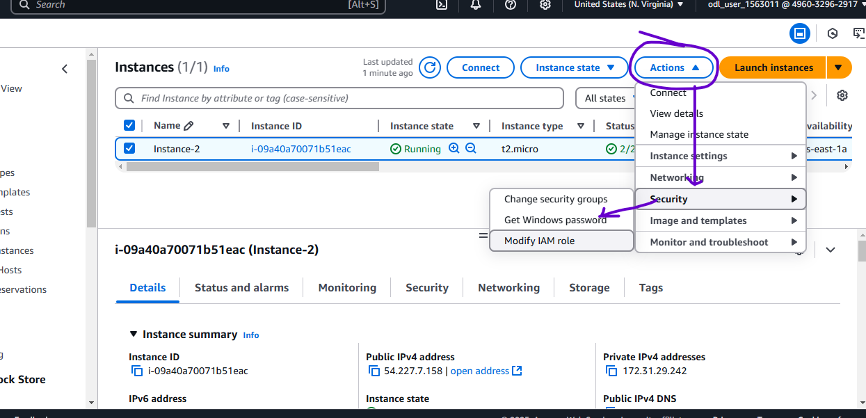

Once you click on get windows password it will take you to the below screen and need to upload the file which was downloaded before after creating security key during instance:

